**Principles of Mobile App Design**

* Organize and label menu categories to be user-friendly.

The importance of navigating and accessibility in design for user experiences cannot be overstated. Users will become irritated if they can't go where they would like to go or locate what they need and they might opt to search elsewhere. Multilevel navigation is an excellent method for enhancing navigation and findability for mobile application with particularly complicated application architecture, resulting in user-friendly online experiences that encourage product trust and drive conversions. Using your intuition to arrange the menu. Check that the information hierarchy corresponds to the mental models of the users. Consider if a customer is more likely to anticipate things to be categorized by brand or item type on an e-commerce mobile application. Would a user anticipate the dropdown to have selections for sneakers, sandals, and boots if they pick the "Shoes" category? Or will they expect to find a submenu displaying every shoe brand carried by the store? This may be clarified by looking at both your user research and your rival research. Sometimes, customers have difficulty interpreting and distinguishing menu categories because they do not correspond to their mindsets for categories. Dropdown categories should be distinct and not overlap. This is especially significant when a user uses a menu as a last resort after exhausted all other alternatives via searching.

Example: Kikuu ecommerce mobile application

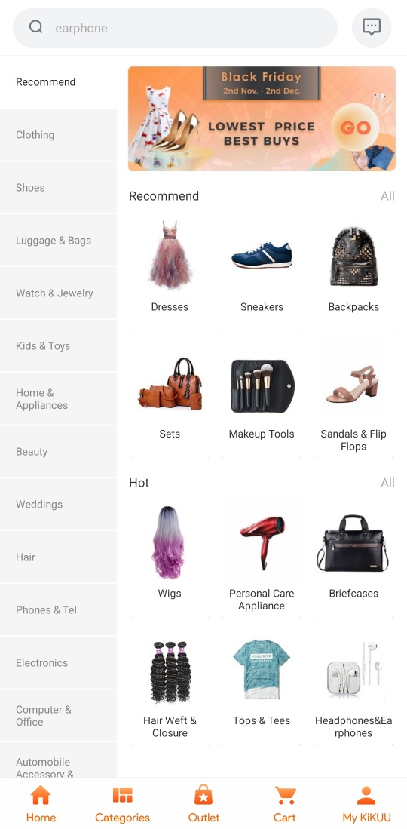

The categories from this application are well organized and distinct so that user can not be confused when navigating through the application finding the product to buy.

* Match the keyboard with the required text inputs.

Application consumers like applications that provide a suitable keyboard for text input. Guarantee that this is consistently done across the application, instead of just for such actions and disregarding others. While using mobile application, there various amount of data that a user can need to enter in the app, when a mobile application development is going on, the suitable keyboard layout should be used so that user will run smoothly while interacting with the application without forcing him /her to change keyboard layout because mobile application uses wrong default layout. There should be specific keyboard layout for different text input where text input should have numeric keyboard layout, alpha numeric text input should have alpha numeric keyboard layout.

Example: chipper cash

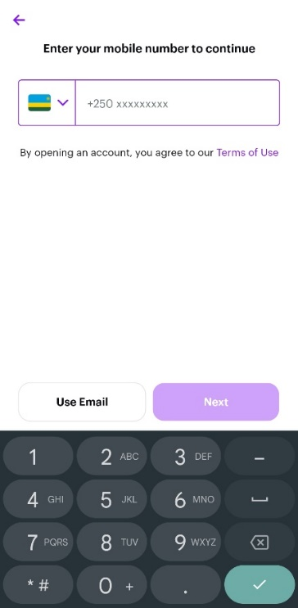

Phone number keyboard layout Email keyboard layout activation code keyboard layout

* Let the user control the level of zoom.

When viewing a picture in mobile application, the customer would like to be able to choose the amount of zooming level depending on the activity she wants to undertake. When the application has a predefined pixel for zooming level, it irritates use users. This can be viewed when a user in zoomed in perspective pushes him/her to look at particular portion of the image which require to zoom in or zoom out as they want. When mobile application do not support smooth zooming in and out, it hinder the user experience and it can lead the customer to live the product and opt to search an alternative which enable smooth zoom in and zoom out so that customer can view any detail he could want on the image.

Example: eBay

